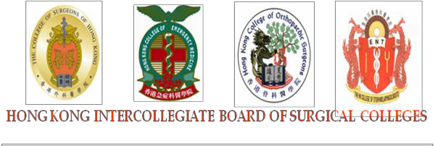

Direct Observation of Procedural Skills in Surgery (Surgical DOPS)

Revised in Jul 2018

Trainee’s name: Date:
Parent Hospital: Current Hospital:

Specialty/Subspecialty*: CTS Ped Surg Plastic Surgery NS Urology O&T ENT A&E ICU

Trainee level*: ST1 ST2 Term*: 0-6th month 7th-12th month
Others (please state level): 13th-18th month 19th-24th month
24th month or above
Name of procedure:
Number of times procedure performed by trainee: ________________________________________________
Hospital Number / Outpatient Number: Location*: Ward OT OPD
Difficulty of procedure*: Easier than usual Average difficulty More difficult than usual

* Please circle as appropriate.

TRAINEE’S REFLECTIONS ON THIS ACTIVITY
What did I learn from this experience?
What did I do well?
What do I need to improve or change? How will I achieve it?
ASSESSOR’S COMMENTS ON THIS ACTIVITY
RATINGS
The assessment should be judged against the standard expected at completion of this stage of training (e.g. initial stage ST1/ST2). Stages of training are defined in the curriculum.
N = Not observed I = Improvement required S = Satisfactory O = Outstanding
Domain | Rating | Specific Comments
1. Describes indications, relevant anatomy, & details of procedure
2. Obtains informed consent, after explaining procedure & comps
3. Prepares for procedure, checks for instruments
4. Gets patient history, administers effective analgesia or safe sedation
5. Proper draping and demonstrates good asepsis
6. Handles tissue gently,
7. Enters correct plane, haemostasis
8. Closure of space, appropriate suturing
9. Techniques up to level of training and safe use of instruments
10. Deals with any unexpected event or seeks help when appropriate
11. Completes required documentation (written or dictated)
12. Issues clear post-procedure instructions to patient and/or staff
FEEDBACK
Verbal and written feedback is a mandatory component of this assessment.
General
Strengths
Improvement needs
Recommended actions

GLOBAL SUMMARY  Level at which completed elements of the PBA were performed on this occasion |  | TICK
Level 0 | Insufficient evidence observed to support a summary judgement
Level 1 | Unable to perform the procedure, or part observed, under supervision
Level 2 | Able to perform the procedure, or part observed, under supervision
Level 3 | Able to perform the procedure with minimum supervision (needed occasional help)
Level 4 | Competent to perform the procedure unsupervised (could deal with complications that arose)

Time taken for observation (mins):
Time taken for feedback (mins):

Assessor’s name:

Assessor’s institutional e-mail address:

Assessor’s signature:

Trainee’s signature:

General guidelines on Surgical DOPS

• Trainees admitted between 1 July 2010 – 30 June 2014 must complete at least 2 during 2 years of BST training; And staple it to your record of curriculum
• Trainees admitted between 1 July 2014 – 30 June 2016 must complete at least 4 during 2 years of BST training; And staple it to your record of curriculum
• Trainees admitted from 1 July 2016 onwards must complete at least 1 of Surgical or Endoscopic DOPS in every 3 months of surgical training*; AND Trainees must complete at least 6 Surgical DOPS during the first 2 years of basic training; AND submit the forms to the College Secretariat together with the half-yearly assessment during January and
July.

* Starting from 1 January 2019 onwards, THERE WILL BE NO EXEMPTION ON DOPS ASSESSMENT for trainees rotating to A&E and
ITU. TRAINEES ARE REQUIRED TO COMPLETE DOPS ASSESSMENT IN EVERY 3-MONTH ROTATION.
@ For the last rotation of BST training, Trainees are strongly advised to complete their competency assessments before they sit for Conjoint
Selection Exercise.
^ Copy of this form should be made and retained by the trainee for his / her personal record of curriculum.

